## horizontal line



Form control email notification

25.07.2016

**─**

Tiju Rajan Abraham

tijuraj123@gmail.com

+61 435 320 677

# Overview

An attempt to develop a custom form field control and a custom form control so as to generate an email notification to the email address specified in the Registration form on form submit event.

# Implementation

1. First off, I created a custom form field control named “emailField”. This control was registered under the ‘Custom Field controls’ section for forms content tab. Used Sitefinity Thunder to generated control and register class.

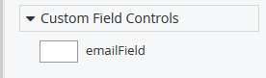

1. Wrote the Regular expression validation code for the email address textbox control in the file ’emailField.asax’. Thus only valid email addresses are allowed to be submitted at server.

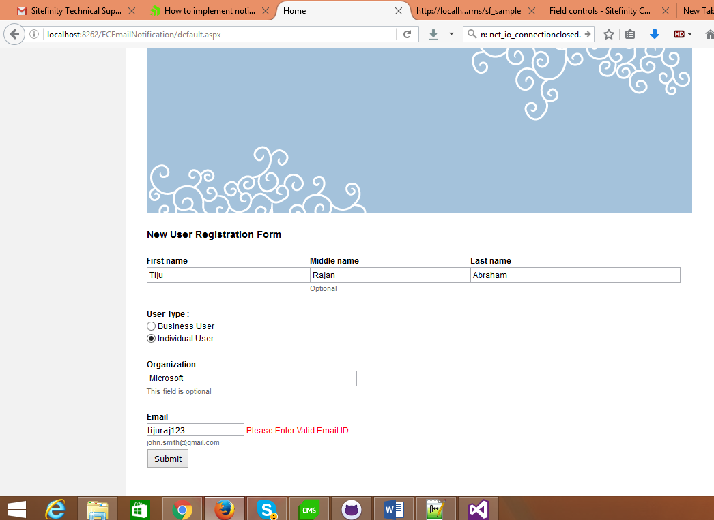

1. Created a custom form control to implement the functionality by extending the Sitefinity forms control.
2. After the custom form control was created, I substituted the build in forms with the new custom form.
3. Override the InitializeControls methord to subscribe to IFormEntryCreatedEvent which triggers when a new forms entry is submitted. This was made possible by Sitefinity EventHub.
4. Wrote the code for FormsEvent Handler to capture the form control data and build an email notification message using StringBuilder.

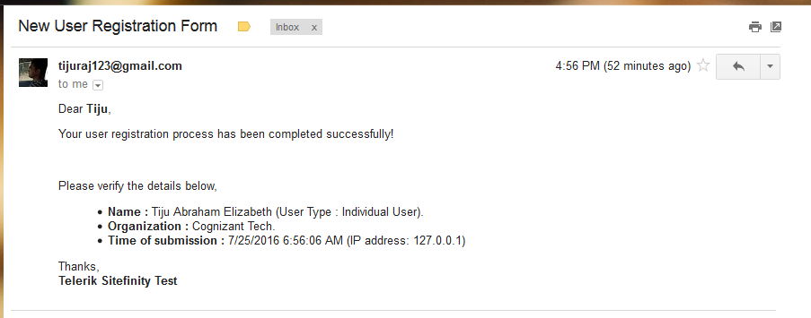

1. Configured the SMTP settings in Sitefinity’s Sytem Email Notifications Settings.

# Difficulties

Currently I am using Gmail SMTP settings with SSL Security level to send emails from Sitefinity. I could use if any SMTP test email servers are available for Telerik.

I referred blogs so that I got many ideas to improve my previous project (Feather MVC Event Selector).

# Reference

I mainly referred blogs by Radosalav Georgiev who gave me the idea to create custom form control to extend the out of box form functionalities. I also had an option to use a marketplace add-on. But I preferred the extension of forms control.

# Improvements

In the Custom Form Control implementation I would like to improve on the way I captured form data.

I would like to use FormsManager instead of IFormEntryCreatedEvent eventInfo which I have used in my project.